SoCaLS Community Newsletter  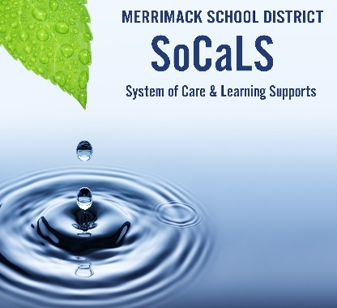  Spend under 5 minutes to learn more!  Check out GIZMO! A young person’s “Pawsome” guide to mental health!    View this video series about the 5 clinically proven mental health skills!! Videos for students, families, and educators!!  System of Care Mental Health Awareness Month Calendar!  -Activities for every day of the month  -Links to special events and resources!  Did You Know…  - During a mental health crisis, call the New Hampshire Rapid Response Access Point:  1-833-710-6477.  - To connect with non-crisis resources and support in NH, call NAMI at 800-242-6264 or dial 211  - National Suicide Prevention Lifeline: 1-800-273-8255  Check out the Community Helpers flier for information about supports available for families.  Check out the Family Resource Guide on the District Website for Community Resources! | May 2022
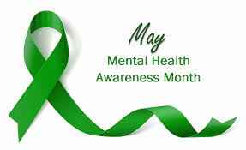

What if we thought about mental health in the same way we thought about physical health, as a part of us that we tend to, practice, and maintain across the life span? Just like our physical wellbeing, we can begin to learn about this dimension of wellness when we are young and continue this journey into adulthood.

In our schools we seek to build developmental relationships, teach and integrate social-emotional skills that enhance learning, and partner with families and caregivers to nurture engaged, confident and joyful learners.

Join the System of Care Family and Caregiver Engagement Team in dedicating time this month to learning and reflecting on our wellbeing with these amazing opportunities:

- Former Chief Justice John Broderick will join us on May 10th at 6:30 PM in the Little Theater at Merrimack High School. If you have never heard him tell his story and speak about youth mental health, you don’t want to miss him! As a result of his personal experiences, he has become passionate about this topic, and has spoken to over 129,000 people across New England, including 83,000 youth. We are delighted to host him and would love to FILL the Little Theater! Thanks to the work of our incredible Health Department at MHS, all sophomores will have the opportunity to hear him speak this month as well.
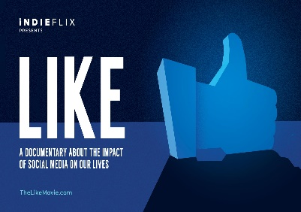
2)If you missed the April screening of LIKE, a film about social media, it is not too late! Between May 9-16th you will be able to access the film on our district website – for 1 week only! Appropriate for ages 10 and up! Look for the link on May 9th! Here is the LINK for viewing!

3)It Takes A Village Mental Health and Wellness Fair! May 21st from 10-1 at Camp Sargent!! Mindfulness walks, a read aloud, MHS student dance and music performances, and craft tables! Don’t miss it!! Click here for more information! Meet the families that your child has been talking about! Let’s build a healthy community, together
.
-Fern Seiden, Director of Student Wellness

Do you have ideas for this newsletter? Would you like to submit an article or resource? Please reach out to fern.seiden@sau26.org.

Giving to others is way to support wellness! Students at TFS created hundreds of images of sunflowers that were delivered to Ukrainian refugees in Poland. At MHS, students raised over $1,000.00 to support humanitarian efforts in Ukraine.

